HAS PTA Annual Thanksgiving Pie Sale
To Benefit Haviland Avenue School PTA

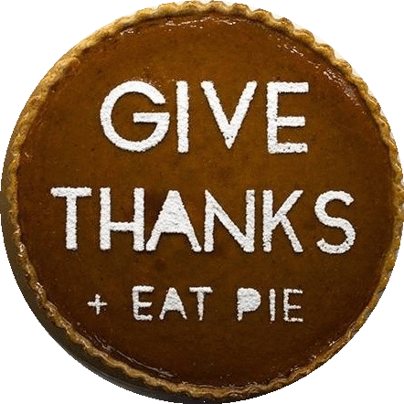
Save some time this Thanksgiving and leave the pies to us!
Pies are just $15/each
Provided by Deluxe Bakery, the HAS PTA is selling 10 inch pies available in 5 flavors.
All orders & money due by Tuesday, November 14th.
Apologies, but no late orders will be accepted.

*Pies will be ready for pick up between 12:30p-4:00p on Wednesday, November 22nd*
Location: Haviland Avenue Cafeteria
Pie Pick Up w during selected timeslots with instructions included in your order confirmation email.

COMPLETE BELOW FORM AND RETURN TO SCHOOL IN AN ENVELOPE LABELED "HAS PTA PIE SALE"

Thanksgiving Pie Order Form

Name:__________________________________________________________________________________
Child's Name (HAS students only):___________________________________________________________
Teacher (HAS students only):________________________________________________________________
Phone Number:___________________________________________________________________________
Email (to receive order/pick up confirmation):___________________________________________________

Number of each:
_______ Pumpkin
_______Apple Crumb
_______Lemon Meringue
_______ Cherry Crumb
______ Coconut Custard

_________ Total number of pies x $15 = _______________________ amount enclosed

______ cash ______ check (make check payable to HAS PTA) ___Venmo (@Rachel-Negro;include date)

